Split test

Student’s Name

Institution Affiliation

Split test on concrete cylinders to determine the concrete's tensile strength without reinforcement
The split tensile strength test is a cylinder-based test for measuring the tensile strength of concrete. The tensile strength is easily measured since the measure splits around the diameter of the cylinder. Despite the fact that the split tensile strength test is an indirect method of determining concrete tensile strength, it has been proven to be the most effective. Concrete's tensile strength is regarded as one of its most important properties. The knowledge of tensile strength is essential for the design and construction of concrete structural elements. While determining the tensile strength of concrete can be challenging, flexural strength is normally determined using a recourse method. The split tensile strength is favoured because it is difficult to assess the real axial load and also because there are often certain stresses caused that cause grips, which cause the specimen to crack at its ends. One of the conditions is that the cylinder of the research specimens be at least a diameter or twice the diameter (Prakash, 2017).
The test specimen is made and cured through the preparation of the materials, conducting a proportion, weighing, mixing the materials, considering ease of working with it, molding and then compacting. From a careful sampling the materials for the concrete will be obtained. The test samples can be made from the cement samples which will be obtained from the bags in the site. Preparation of the materials will be made under the room temperature. The cement materials will be taken to the laboratory and mixed thoroughly either by hand or through a proper mixer machine to ensure compatibility. The mixture should then be placed in a dry condition and the separated into a fine and coarse fractions. They should then be recombined the batch into the required grading to make it suitable. Weighing the cement, aggregate, and water could yield a result of around 0.1 percent of the total weight of the batch. Water loss can be reduced by thoroughly mixing the concrete, which can be achieved by hand or with a mixer machine (Sciencedirect, 2021).
The primary goal of the split tensile strength test is to determine the splitting tensile strength of concrete. This would be accomplished using measuring machines, containers and pans for transporting the necessary materials and the mixture, a circular cross-sectional rod, a testing machine, approximately three cylinders, and two jigs, one of which would be used to align the concrete cylinders and the other will be used for bearing strips.
The procedure of the splitting test tensile is as follows:
The first step is taking the specimen that is wet from the water after approximately 7, 28 of curing. Any other desired age can be used to estimate the tensile strength.
The water from the specimen is then rubbed away, and lines are drawn on the specimen's diameter to ensure that the lines are in the same axial position. After that, the specimen's weight and dimensions are registered.
The machine for machine for test compression at a required range is then set. After this the plywood strip is then placed on the lower plate followed by the placement of the specimen. The upper plate is then brought closer in a way it just touches the plywood strip.
At a range of about 0.7 to 1.4 MPa/min, the load is applied without any shock continuously. The breaking load is then noted down.
The measurements are completed after all of the procedures have been completed. T=2P/piLD is used to measure the specimen's splitting tensile power. Where T denotes the splitting tensile strength and Mpa P denotes the maximum load indicated by the measuring equipment. The diameter of the specimen is N, and the length of the specimen is L in millimeters. The result should show the concrete's splitting tensile strength in N/mm2. The method's key benefit is that the compression test can be performed on identical specimens. It is a simple method that, when compared to other tests, provides ease of performance (theconstructor, 2021).
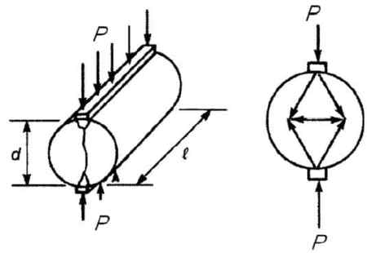

References
Sciencedirect, Inc. (2021). Splitting Tensile Test.Retrieved from https://www.sciencedirect.com/topics/engineering/splitting-tensile-test
Prakash, S. (2017). Split Tensile Strength in Concrete.Retrieved from https://www.slideshare.net/selvaprakash549/split-tensile-strength-in-concrete
Theconstuctor, Inc. (2021). Splitting Tensile Strength of Cylindrical concrete specimen.Retrieved from https://theconstructor.org/concrete/splitting-tensile-strength-test-cylindrical-concrete-specimen/2116/

